[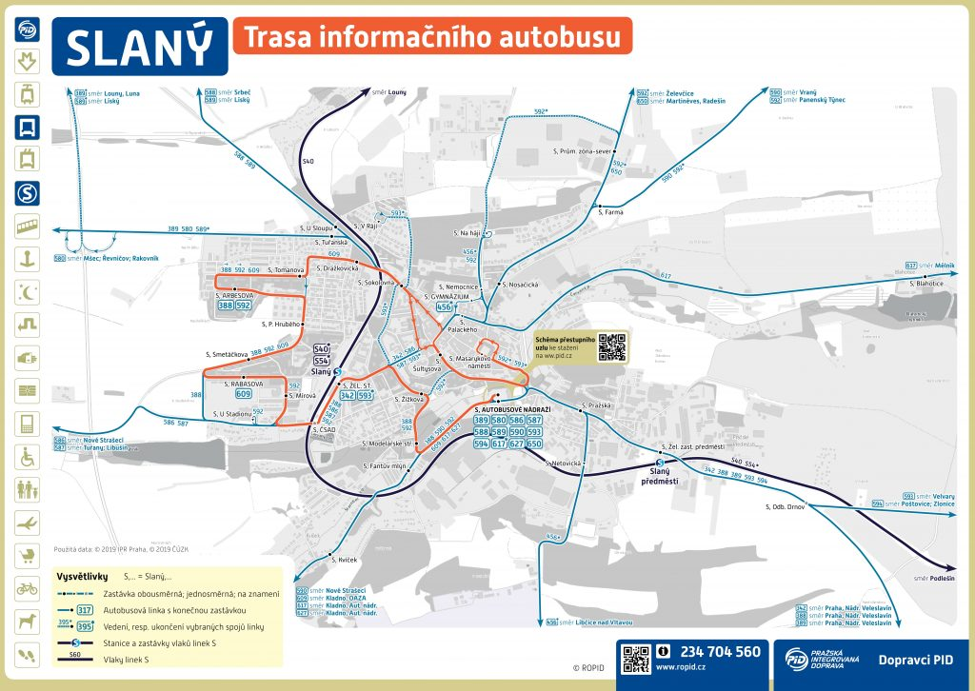](https://otevrenenoviny.cz/wp-content/uploads/2019/08/img_5d550990a072a.png)